Title: Egg Drop Laboratory Report.

General Purpose: Find out how to drop an egg from the second floor of a building without breaking it. Use aerodynamics and low mass to make the egg take the most time possible to fall.

Specific Purpose: How can we make an object with a small mass and small volume be able to fall from the second floor taking more than two seconds to fall?

Background Information: During previous lab reports, we learned basics about physics. We learnt that velocity is the change of position in a unit of time. We also learnt that distance is the change of position, displacement is the change of direction, and that motion is the act of changing position. Acceleration is when something starts at a speed and quickens the velocity.
The equation to find speed is d/△t, and to find velocity is △x/△t. In order to find average velocity, you can use the equation xf-xi/tf-t. When graphing, something with a constant velocity will have a linear graph, while acceleration will have a non-linear graph. We also had a basic understanding that mass does not affect gravitational acceleration.
A normal egg takes about 45 Newton’s of force to break. That means that we’ll have to make less force be applied to it.
For background, we also brainstormed some materials that we could use in our project. We thought of the following: straws, tape, rubber bands, foam, sponges, cotton, bubble wrap, plastic cups, pipe cleaners, plastic squares, and cardboard. We thought of these because most are lightweight and fluffy and flexible, which is what we need for this project. They would also increase the time of impact, which would essentially help the egg not crack, as we learned from our reading.
From doing further research from three websites, we were able to discover more about using our previous knowledge to make an egg not break when it fell.
After doing a bit of research, we learned a bit more about air resistance and free fall because that was what this project essentially is. We are putting a egg into free fall, and are trying to create as much air resistance as possible to keep it up in the air for the most time possible. So, we researched this subject. The more you know about a subject, the better it is for you.
All objects free fall at an acceleration of 9.8m/s squared, or 10 m/s squared to keep it simple. Newton’s second law of motion (the one that states that f=ma) can be used to analyze the moving under the influence of gravity and air resistance. Free fall is a type of motion when the only force acting is gravity. So, objects that go through free fall are not experiencing the force of air resistance, only gravity. While falling free fall, all objects, no matter the mass, travel at an acceleration of 10 m/second squared.
According to Newton’s second law, acceleration depends upon force and mass. This means that it would make more sense to have, say, an elephant accelerate faster than, say, a baby during free fall because elephants are obviously heavier than babies. However, there is a inverse effect on the increased mass of this elephant’s acceleration. For example, if the elephant weighed 1000 kg, it would offset by the inverse of it’s weight (1000 kg), thus neutralizing the weight. If this (an inverse offsetting the original weight of the object) happened to, say, a 1 kg baby, the baby’s 1 kg would be inversed, and it’s weight would also be neutralized. So, in theory, the elephant would the baby would have the same ration of force to mass, which would make both free fall at 10m/second squared.
For background, we also decided to research aerodynamics because we thought that we should have a good general knowledge of it before completing this lab. Aerodynamics is the way air moves around objects. So, anything in the air, such as an airplane, reacts to aerodynamics. There are four forces of flight: lift, weight, thrust, and drag. They affect how everything travels in the air.
Weight is a force that comes from gravity pulling objects to its center. Everything on Earth has weight. When objects with certain weights fall on Earth, gravity and Newton’s laws take over. For example, an airplane needs something to push the opposite way the gravity. The weight is the key to determining the force.
Lift is also very important in physics. This is the push that makes objects go up. For example, the wings of an aircraft enable it to fly. The wings are especially designed to help the airflow over the top as opposed to the bottom. This leads to the effect of less air pressure on top of the wing. To get a stronger airflow, some objects use curves, sails, or blades. For example, sailboats, helicopters, airplanes, kites, and birds all use lift.
Drag is the force that tries to slow objects down and makes it harder to move. For example,it is harder to walk in a swimming pool than on a sidewalk. Shapes of objects also affect the amount of drag. For example, round objects have less drag than rigid ones. Thrust is the opposite force of drag. It pushes things forwards. Propellers and engines provide thrust. An object can fly only if it has more thrust than drag.
Finally, we decided to research air resistance. Air resistance adds complication to the “nature of air”. For example, you go through air resistance when you run with an open umbrella in the opposite direction of the wind. So, air resistance is a frictional force which slows down objects that are moving through the air. Why? Air is made of tiny particles (which we learned about at the beginning of the year) which rub themselves onto the surface of a falling object. This slows down the rate of the acceleration because of the downwards pull of the gravitational force.
Surface area increases the air resistance. So, the greater the surface area, the greater the air resistance. This is because there will be more particles on the object that will be able to rub and collide with the air, creating friction. According to the website we used “the faster an object is falling, the greater the air resistance.” This is because the object will increase the frequency of impact and the force of impact, which will, of course, result in a greater friction. So, when objects fall to the ground with a great air resistance, they may stop accelerating, but may begin to travel at a constant velocity. In this case, the forces of air resistance and gravitational forces in the object and air and gravity would be balanced.

Bibliography:
"Free Fall and Air Resistance." Free Fall and Air Resistance. N.p., 2013. Web. 27 May 2014. <http://www.physicsclassroom.com/class/newtlaws/u2l3e.cfm>.
Dunbar, Brian. "What Is Aerodynamics?" NASA. NASA, 2013. Web. 28 May 2014. <http://www.nasa.gov/audience/forstudents/k-4/stories/what-is-aerodynamics-k4.html#.U4Ylofn58rU>.
"Air Resistance." Air Resistance. N.p., 2010. Web. 28 May 2014. <https://www.le.ac.uk/se/centres/sci/selfstudy/air.html>.

Hypothesis #1: We thought that we could use sponges (the kind you clean dishes with) to stop the egg from breaking. Sponges are lightweight and fluffy. Cotton is also lightweight and could cover our egg completely, so we decided to protect our egg in it, too. We also thought that we could stick the sponge box on a large sheet of light styrofoam. We hoped that this would make the egg fall slower due to aerodynamics, which would extend the time the egg would take to fall.

Hypothesis #2: We thought that we could use straws, pipe cleaners, and rubber bands to stop the egg from breaking. We wanted to put the pipe cleaners in the straws to prevent them from bending, then make the straws into 4 square shapes. We wanted to stick the squares together, then use rubber bands to make the egg hang in the middle of the cube. We thought that this project would be lightweight and could possible protect the egg if it was secure inside the cube.

Hypothesis #3: We thought that we could try and improve our first hypothesis. We thought we could use sponges (the kind you clean dishes with) to stop the egg from breaking. Sponges are lightweight and fluffy. Cotton is also lightweight and could cover our egg completely, so we decided to protect our egg in it, too. We also thought that we could stick plastic cups to each of the sponges to break the fall. Finally, we decided to put plastic squares connected to the cups. We hoped that this would make the egg fall slower due to aerodynamics, which would extend the time the egg would take to fall. We chose these materials because they are all lightweight.

Materials to Consider:
- Straws
- Tape
- Rubber bands
- Foam
- Sponges
- Cotton
- Bubble wrap
- Plastic cups
- Pipe cleaners
- Plastic squares
- Cardboard

General Procedure:
- Get materials
- Draw blueprint of ideas
  - Prototype One: cover egg in lightweight sponges to cushion landing and stick to large foam sheet
  - Prototype Two: make cube of straws with pipe cleaners as support and attach rubber bands to cube with egg floating in middle (supported by rubber bands)
  - Prototype Three: use prototype one, but add cups to each sponge. Then, place plastic sheet to cups to make surface area
- Choose best idea: Prototype Three
- Do the experiment

Procedure of Prototype #1:
- Get materials:
  - foam wrap
  - tape
  - cotton
  - sponges (6)
  - one egg
- Make a blueprint of your model.
- Make a square out of the sponges.
- Put cotton inside of it.
- Stick the sponges on top of the foam sheet.
- Insert egg into the sponge/cotton house.
- Drop from 4.95 meters.
- Record results.

Procedure of Prototype #2:
- Get materials:
  - 16 straws
  - tape
  - 12 pipe cleaners
  - 6 rubber bands
  - one egg
- Make a blueprint of your model
- Place pipe cleaners in straws for support
- Stick straws together into 4 squares
- Connect four squares into cube using tape
- Stick rubber bands to straws
- Attach rubber bands to each other so that many overlap in center of cube
- Place egg in place secured by rubber bands
- Drop from 4.95 meters.
- Record results.

Procedure of Prototype #3:
- Get materials:
  - tape
  - cotton
  - sponges (6)
  - one egg
  - six plastic cups
  - four plastic squares
- Make a blueprint of your model.
- Make a square out of the sponges.
- Put cotton inside of it.
- Stick a plastic cup to each sponge
- Stick four plastic squares to two cups to make more surface area.
- Insert egg into the sponge/cotton house.
- Drop from 4.95 meters.
- Record results.

Data:
Egg- 56 grams
Height- 4.95 meters

Prototype 1:
Description: | Dimensions: | Weight: | Time to Fall: | Did Egg Survive?
6 sponges arranged in a cube with cotton lining the inside. A flap made out of foam to take the egg in and out of the box. Cube of sponges placed on foam sheet. | 15cm by 17 cm | 103 g | 2.3 seconds | No. This failed.

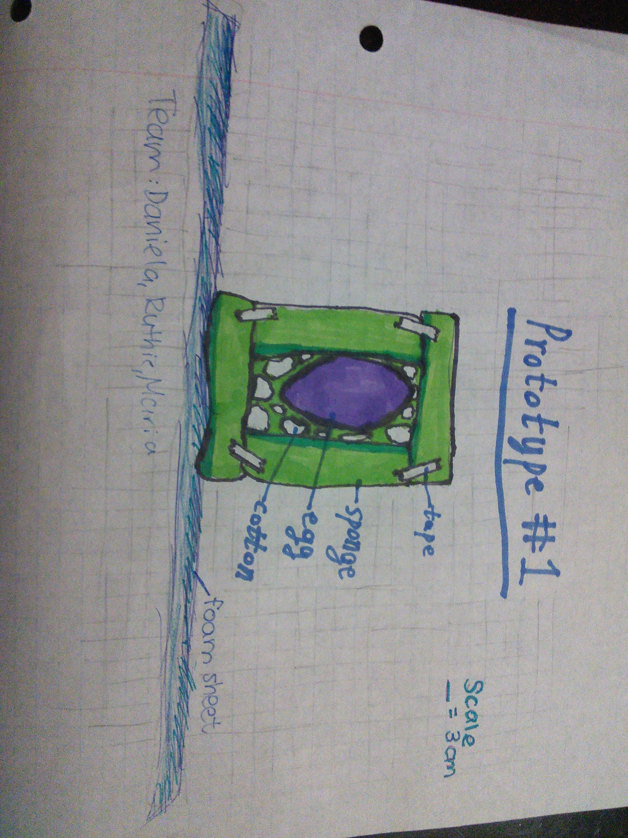

Prototype 2:
Description: | Dimensions: | Weight: | Time to Fall: | Did Egg Survive?
4 rectangles of straw with pipe cleaners inside the straws attached into a box as netting for the egg. | 35 cm by 35 cm | 25 g | 0.81 seconds | No. It failed.

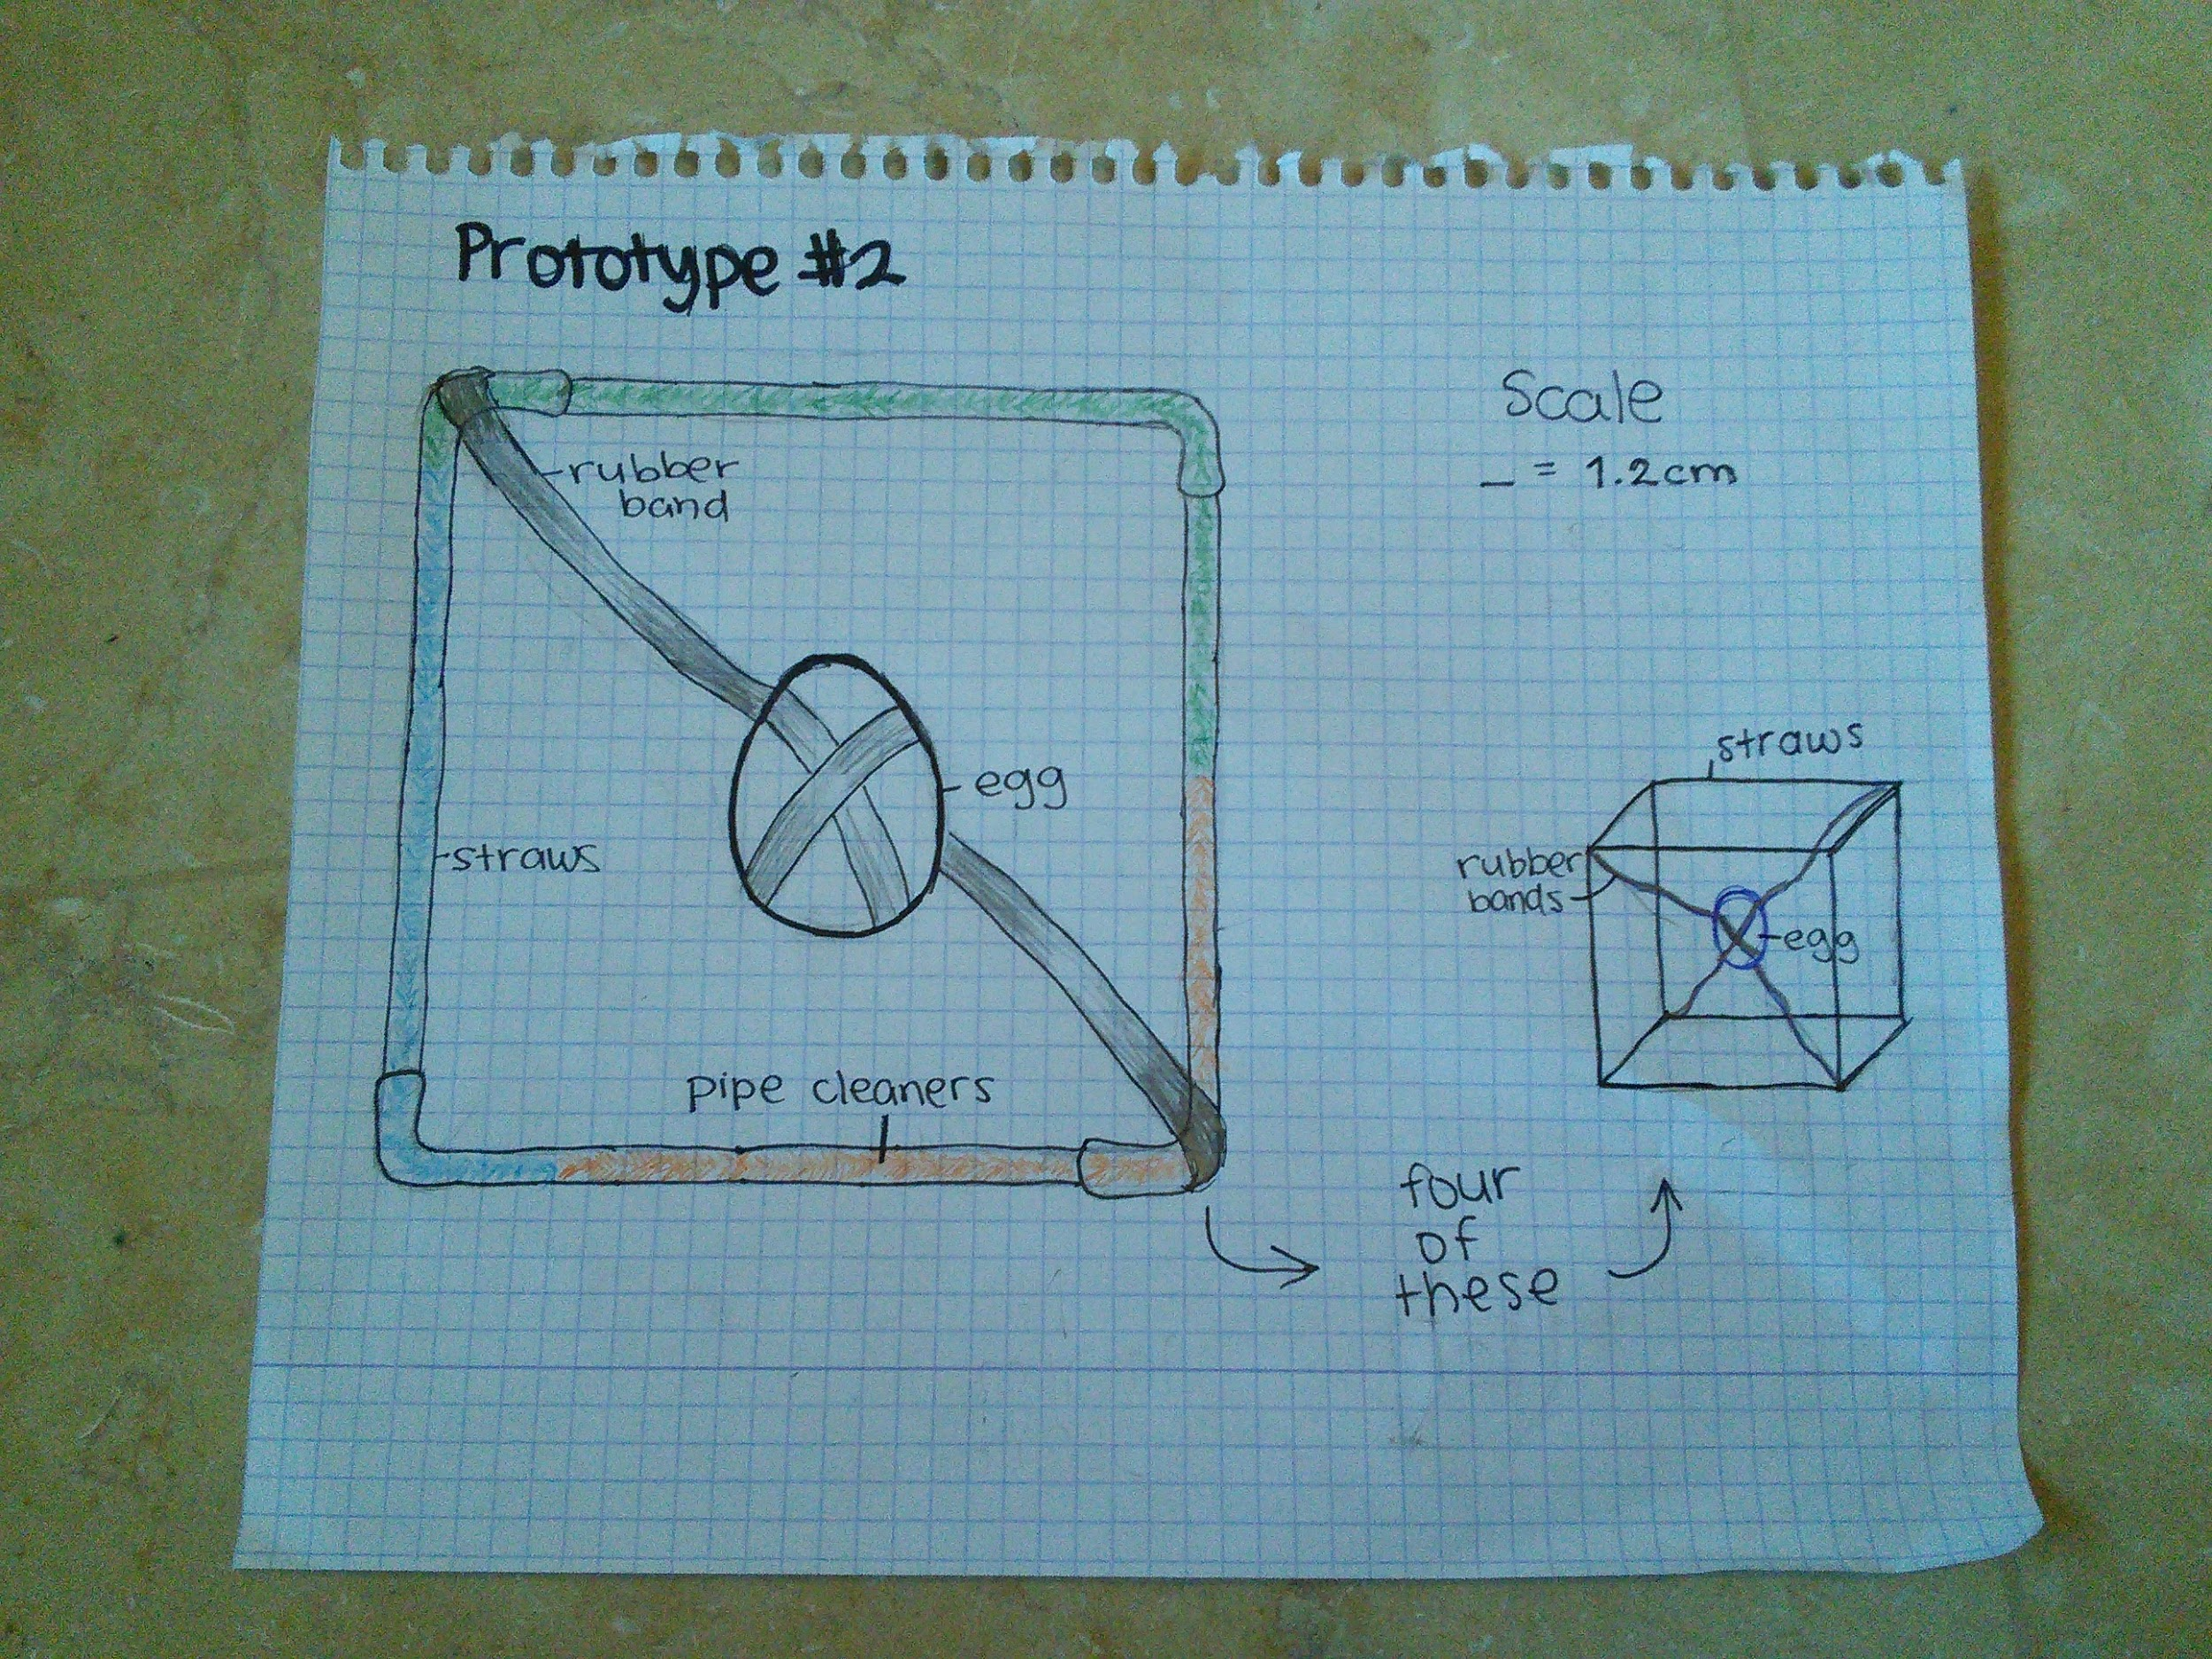

Prototype 3:
Description: | Dimensions: | Weight: | Time to Fall: | Did Egg Survive?
6 sponges arranged in a cube with a flap made out of foam to take the egg in and out of the box. One cup stuck to each sponge, and plastic stuck to cups. | 34 cm by 34 cm | 200+ grams without egg | 1.22 seconds | Yes it did.

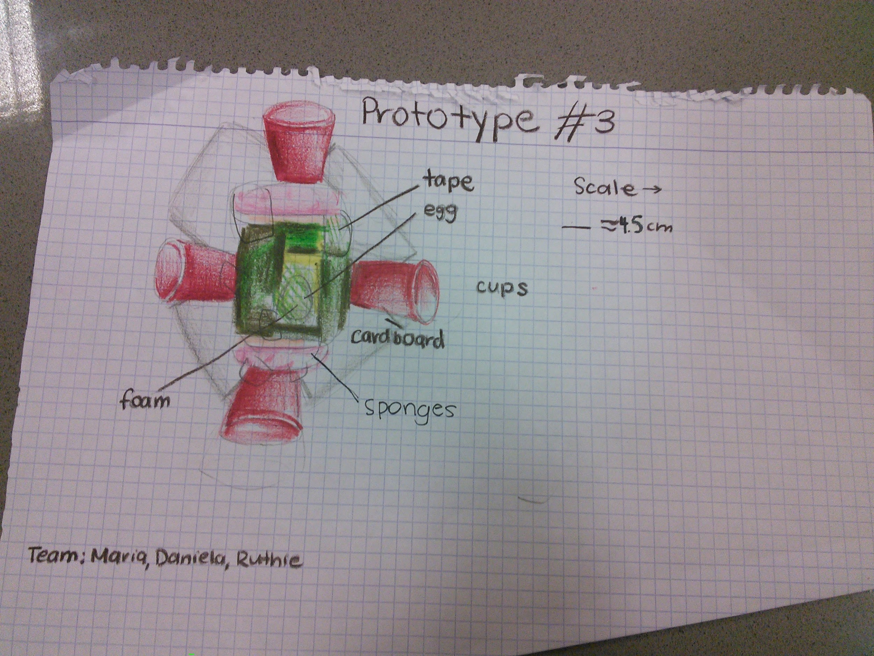

Dependant: How the egg falls (mass, the amount of time it takes, volume) and if it breaks
Independant: The container that we put the egg in.
Control: An egg without any coating dropped from the second floor.

Analysis:
- What do the observations show?
Our calculations and observations show that it is possible to drop an egg from the second floor without breaking it using many lightweight materials. The observations show that it is best to use light materials, but also materials that add surface area, because they will make the egg’s protection light and will fall slowly, decreasing the force.
- Did your first plan work? Why?
No our first prototype was unsuccessful. It was on the right track, so we made improvements to it in our third prototype. For starters, the sponges we used were too thin, so they did not take the impact from the fall, but sent it to the egg. We also packed the egg to tight with cotton for protection. This gave the egg no space to move around, so it ended up receiving too much force and broke. Finally, we had the idea of using a foam sheet to increase volume. It would have worked, but the sponge cube was right in the center, so the sheet ended up folding up instead of staying flat. So really, it just increased the weight. We were on the right track with this prototype, but we made too many little mistakes that made it unsuccessful.
- Did your second plan work? Why?
No, it didn’t work. We thought that if we made a structure out of straws, and used rubber bands to support the egg, the egg may not break because the force would be spread between all of the materials. This prototype would also be very lightweight because the materials were so light. However, the opposite happened. The straws crumpled, even though the pipe cleaners were supporting them, and the rubber bands ended up pulling the egg too hard, cracking it lightly. When the straws crumpled, the egg smashed to the floor, and of course, broke. However, this project was also never going to be that successful because the structure had no surface area, so it would fall very quickly. However, if it had worked, it may have won for lightest weight and smallest dimensions, but it didn’t work. We learned that we had to use more support for the egg in the next prototype.
- Did your third plan work? Why?
Yes, the third prototype worked just as planned. The materials we used included lightweight, flexible, and compressible sponges, which protected the egg. The egg was supported specifically by foam wrap. We put it around the egg loosely so that the egg would not be squeezed and broken after being wrapped. Around this we supported this with tape and outwards cups. These cups reduced the force applied onto the egg, so instead of the egg breaking, the cups hit the ground first and therefore less force was there to make the egg break. The force was only applied to the outside, which happened to be the cups. The egg, in its protective coating, survived and could not possibly crack or break. Also, we stuck plastic squares to the cups. This increased the surface area of the prototype, which therefore made it fall slower. As stated before, we used very lightweight materials. However, we used many materials, so it all added up into a very large mass. We based this prototype off of the first prototype.
- Were your results different from the class’s results? Why?
Yes, of course our results were different. Everyone in the class did different projects. We all had different purposes and all used different materials with different structures. The whole point of this project was to be creative, and that’s what we all did. So, none of us did this wrong, although some groups did a better job at keeping the weight low, keeping the egg falling for longer, and making the dimensions smaller than other groups.
- What equations did you use?
We used the equation p=m*v which means momentum is mass times velocity.
- How did your background help you during this lab?
We used our background information to teach us the basics of air resistance, aerodynamics, and free fall. We definitely used air resistance in our lab because we had a large surface are which resulted in more friction. We used our knowledge of aerodynamics to choose a rounded design of cups because our background suggested using them. We used our basics of free fall to know how what not to do, and we knew we had to avoid making our egg free fall. Also, we learned during background that an egg needs 45 Newton’s of force to crack. That means that we had to apply less force than that to our egg.
- What are the forces acting on the egg as it falls?
The forces acting on the egg include gravity because as the egg falls to the ground, gravity and Newton’s laws take over. Also, air resistance also began to act during our experiment. This means friction started to form between our object and the air.
- How can you control the forces that cause the egg to break?
We cannot change these laws of motion and gravity, but we can lessen the effect. We can do this by using flexible, compressible and protective materials to keep the egg from breaking. We can also make the time longer to make the force applied to the egg smaller.
- What are the common characteristics of the materials that protected some eggs?
The materials needed to be flexible, light weight, and had to be capable of absorbing force. For example, the sponges were lightweight, flexible, and could absorb force, as could the foam layering. The cotton also has these three characteristics. However, the cups we used didn’t. They worked because they were not directly in contact with the egg, but were protecting the sponges that were protecting the egg. By being stiff, they were able to increase the egg’s impact time, which would essentially lessen the force. However, this is our only exception.
- Did layering of materials play a role in protection?
Yes, we layered many materials. For example, we covered our egg in foam, covered the foam in sponges, and covered the sponges in plastic cups. We all thought that this would provide maximum protection because the egg would not touch the ground, and the materials protecting the egg would not touch the ground, meaning there would be a longer impact time, which would lessen the force applied to the egg. This protected the egg. We saw that other groups did not protect their eggs as much as we did. In fact, one group’s egg broke because of their lack of protection.
- How does your container to protect the egg share characteristics with the restraint systems in cars?
Cars have seat belts and airbags, and our protection system worked a little bit like these two protection methods. For example, airbags and seat belts increase the impact time of the fall or crash, which makes the force less. This is because f=m*a or force=mass*(change in position/change in time). So, if you increase the change in time, the force decrease. So, we used sponges, foam, and cups, while cars use airbags and seat belts, but in the end, both are following the same principles.
- Did you win any of the competition?
Our group was actually very surprised to see that we won the final competition of our class! We won this because we decided to focus our project onto winning one specific category, instead of being mediocre at everything. We decided that we wanted to have the slowest time falling because you said it was the most important part of this project. We also tried to use light materials to not miserably fail in mass, but that did not turn out very good because we used too many materials. Also, we didn’t try to make such a small protection, but more of an average sized one. In the end, our time falling to the ground was extremely slow, so we won that section. We lost for mass because our protection could not even be weighed because the scale said ERROR. Our mediocre dimensions were not that small, but they did give us points, resulting in us winning this in our class.

Error: My group worked well and did not make any errors in the conducting of this experiment. However, this really depends on how you look at our project. Our first two prototypes were unsuccessful and our final one was very heavy and bulky, so we technically made some “mistakes” because none of the prototypes were perfect. But, we learned from these mistakes, and each prototype was an improvement over the other. In fact, we managed to win the competition in the end.

Conclusion: Our first hypothesis was partly right, our second was wrong, and our third was right in the sense that the egg didn’t break. However, none of our hypotheses were completely correct because our end result had a large volume and too large a mass, which was not the point of our project. However, it did let the egg survive, so we were successful in a way. And we won. But, our hypothesis didn’t really prove all of the focus question. Although we used lightweight materials (plastic cups, sponges, light plastic, and tape) on our final project, we used too many materials, which resulted in a too heavy prototype. Also, the materials took up a lot of space, which resulted in a large volume. However, if we had had more time, we probably would have been able to make this lab better with lighter materials and a smaller volume.
During this lab, we learned how the equation of momentum could be used in real life situations, instead of just in math and science books. We learned about this because we used this equation (p=mv) while doing this experiment to make sure that the egg would survive. We also learned, partially because of the equation, that the longer something takes to fall, the less impact force will be placed. We see this in day to day things. For example, in car crashes, an airbag is released from the car to make the time that you fall forwards less, which will reduce the force applied on you, which will most likely save your life. Also, we learned that we need good crash helmets. For example, the best materials for helmets should be compressible and flexible. These facts were reinforced in the SRB book.
Our group was able to show our creativity through our three designs. However, we all agree that we liked our final design the best because it was the best, most creative design in the whole grade, probably in your whole teaching career. We wonder if you will ever see something even close to this fabulous, time-consuming work. We hope you enjoyed this project as much as we did. Hopefully, we will have more projects like this in the future. As you probably learned this year, we are the strongest group when we work together. All in all, this project was extremely fun and was also a genuinely great learning experience. Our group won even though the chances were not in our favor, which has taught us to never give up. We learned how to keep an egg from breaking with trial and error, and we all think that everyone can agree that we all want to do more projects like this in the future. All three of us agree on this conclusion.

Further Information: If we did this project again, there are a few changes we would make. We would try to keep our materials as light as possible and we would try to use the minimum amount of materials as we could while still protecting the egg. In our project, we did very well with the volume and timing (meaning we used good materials), but next time we would use more lightweight materials (our project was slightly heavier than we could have made it.) In general, if we were to repeat this project, we would not have adjusted it too much because we won the competition and we tried very hard on the design. We are very pleased with this project, and we think it was a great way to end the year.
The main cause for our heavyweight was the tape we used. We kept on adding more and more tape to the project, and the weight added up. So, if we had kept the weight to a minimum, this would have probably been a different project. Also, we looked around our class and noticed that the other groups were using just enough protection to keep the egg from breaking, but we added too much protection. If you think about it, we were a mother protecting it’s baby, and everyone else was a father protecting it’s baby: just enough protection to keep it safe. Next time we would probably think about doing that, too.
If we had put more thought to it, we probably would have eventually come up with the design of the balloons. It did cross our minds, but we were not sure if it counted as a parachute. The group’s design was an egg covered completely by balloons. This design was light and fell slowly, but it probably was not the smallest when it came down to dimension. However, it was a very smart design, and our group may have eventually thought of it. Or not. You never know.
As stated before, we probably would have used less protection while covering our egg the next time we did this project. Our project was way too heavy, and the reason for that was the overuse of materials. We could have easily not used sponges in our project and maybe just put the egg in a cup in the middle, still surrounded by foam. We may have gotten rid of the cups, and stayed with the rest of the project (however, this was our first prototype, and it didn’t work). We could have used completely different materials such as straws (like our second prototype). You never know. The thing is, we stuck with our prototype, and although it had some flaws, our group was happy with it and it brought us victories. We could have ended up with a completely different design that was light, but fell quickly to the floor. We could have made a small design that was slow, yet weighed a lot. It’s hard to make a perfect prototype.

